Broccoli, Brussels Sprouts, Bok Choy, Oh My! Tips for Celebrating National Eat Your Vegetables Day

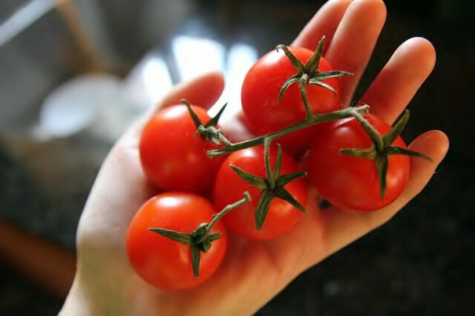
Today is National Eat Your Vegetables Day and that means that it’s time to veg out. No, not on your couch—in your kitchen!

Vegetables give your body the nutrients you need to be healthy and strong. Not only that, but they taste delicious and can be prepared in many different ways. Whether they are raw or cooked; fresh, frozen, canned, or dried/dehydrated; or whole, cut-up, or mashed, it’s incredibly easy to incorporate vegetables into snacks and at mealtime. Here are some tips for enjoying veggies at their best:

"Veg out" for National Eat Your Vegetables Day!
- Buy fresh vegetables in season. Fresh vegetables cost less and are often at their most delicious, peak flavor!
- Buy vegetables that are easy to prepare. Pick up pre-washed bags of salad greens and add baby carrots or grape tomatoes for a salad in minutes. Buy packages of veggies such as baby carrots or celery sticks for quick snacks.
- Many vegetables taste great with a dip or dressing. Try a low-fat salad dressing with raw broccoli, red and green peppers, celery sticks or cauliflower.
- Keep a bowl of cut-up vegetables in a see-through container in the refrigerator. Carrot and celery sticks are traditional, but consider red or green pepper strips, broccoli florets, or cucumber slices.
- Decorate plates or serving dishes with vegetable slices for a delicious and nutritious garnish.

In honor of National Eat Your Vegetables Day, why don’t you veg out and try out these delicious, healthy vegetable party foods? And for more healthy ideas to inspire you to make half your plate fruits and vegetables, check out our MyPlate-inspired recipes.

Tasty Tomato Salsa
- 6 tomatoes, chopped (add color by using yellow and red tomatoes)
- 1/2 white onion, chopped
- 2 tbsp canned, diced mild chiles or 1 small jalapeno pepper, seeded and chopped
- 1/4 cup chopped fresh cilantro, juice of 1 lime
- 1/2 tsp of chili powder and black pepper (optional)
In a medium bowl, mix all ingredients. Serve with baked tortilla chips.
(Source: USDA’s Team Nutrition)

Tasty Tots
- 5 cups fresh sweet potatoes, peeled, coarsely shredded
- 2 cups canned low-sodium garbanzo beans (chickpeas), with liquid
- 1/2 cup fresh green onions, finely chopped
- 2 tbsp vegetable oil
- 1/2 tsp salt
- 1/2 tsp granulated garlic
- 1/4 tsp ground black pepper
- 1/2 tsp onion powder
- 1/2 tsp ground cinnamon
Preheat oven to 350° F
Place shredded potatoes on a large baking pan sprayed with a nonstick cooking spray. Bake at 350° F for 20 minutes or until slightly tender. Do not overcook.
Increase oven temperature to 400° F.
In a food processor or blender, purée garbanzo beans, including the liquid, until smooth.
In a medium mixing bowl, combine shredded sweet potatoes, puréed garbanzo beans, green onions, vegetable oil, salt, garlic, pepper, onion powder, and cinnamon. Mix well. Cover and refrigerate for 40-45 minutes to make tots easier to form.
Spray a large baking sheet with nonstick cooking spray. Using a cookie scoop or a spoon, roll 36 tots. Place 1 inch apart on baking sheet. Lightly flatten the tops of the tots with a spoon or a fork. Bake at 400 °F for 10-12 minutes or until lightly brown. Serve hot.
(Source: USDA’s Recipes for Healthy Kids Cookbook for Homes)

Dr. Robert Post is the Associate Executive Director of USDA’s Center for Nutrition Policy and Promotion.

